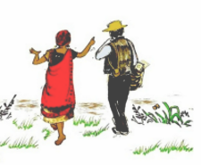
Guidelines for writers who wish to contribute to the Barefoot Guide on Inclusive Development

In Brief
The Barefoot Guide Connection, in alliance with the Dutch platform Leave No One Behind, has initiated the production of the fifth Barefoot Guide, which focuses on the practices of inclusive development. Work has already begun, most significantly during a five-day ‘writeshop’ in April this year of 2016, which brought together fourteen experienced practitioners from nine countries in Asia, Africa and Europe.
This new Barefoot Guide gathers together a range of valuable experiences of successful and interesting social change practices that deal with exclusion, inequality and marginalisation, to foster inclusion and equity across a wide range of social contexts. The intention is to contribute key experiences, learnings, insights and approaches to the work of inclusion-focused practitioners, donors, policy-makers and students.
We have decided to invite anyone who has a valuable inclusive development development practice or experience of some kind, to contribute a written piece for us to consider including in the publication. If we think that the story, idea or practice that you would like to offer could find a good place in the book then we will be happy to work with you to write it or possibly improve what you have already written.

Motivation
Across the world millions of people are excluded from the benefits of being citizens. This might be because they are women or disabled, elderly, sick, displaced refugees, members of ethnic minorities, have a criminal record etc. etc. Some are excluded for several of these reasons, living miserable lives on the edge of society, ignored and isolated. Many efforts to include such people fail because they do not understand the complex nature of their exclusion and the kind of work that needs to be done to support people to become empowered and to include themselves and to become included.
As the United Nations Sustainable Development Goals are implemented, with the intention that we will “leave no-one behind”, inclusive development practices are key to achieving these goals, for which clear and shared articulations of these practices are required, drawn from real experiences. In many countries innovative, integrated and sustained programmes, involving multiple stakeholders, have already changed the lives of many thousands of excluded people who had given up hope. In the process those involved (practitioners and excluded people) gained invaluable experience of benefit to others pursuing similar goals. If this experience is not shared there is a real danger that the same instrumental and mechanistic practices, that characterised many of the projects used to advance the Millenium Development Goals, will be used, missing the opportunity for authentic and lasting change.
Barefoot Guides provide writings that are based on real experiences of successful (and some unsuccessful) practices. The creative and collective writing workshop processes, or “Writeshops”, bring together a range of experienced practitioners to enable a sharing and an articulation of the deep practices that underlie strategies and activities that lead to meaningful and sustainable change. Writeshops provide a unique and innovative process that enables practitioners, who often struggle to write about their own practices, to surface, share and collectively deepen their understanding of what is the “real work” of change, thus making it available to others.
As with the other Barefoot Guides, the result will be a helpful, readable and well-illustrated guide, aimed at all practitioners in the system, whether those working on the ground or those making policy or distributing funds, thus supporting common and coherent approaches.

What are the Barefoot Guides?
See www.barefootguide.org
The Barefoot Guides are free online and published books and related resources that give practitioners, donors, policy-makers and students access to stories, practices and knowledge on development themes. In a world dominated by unreadable academic texts they come as accessible and readable books that are deceptively simple without being simplistic. Being accessible to such a wide range of people, up and down the system, the Guides serve to bring coherency and consistency to practice, lessening mismatches between policy and practice.
The Guides focus on surfacing real and practical experiences from which theoretical insights are drawn or deepened. In many ways they represent the “state of the art” from the field.
All Guides are published on the website www.barefootguide.org, accompanied by many practical exercises, tools and frameworks, and in up to nine different languages: Arabic, Bahasa, Chinese, English, French, Portuguese, Spanish, Swahili and Vietnamese.
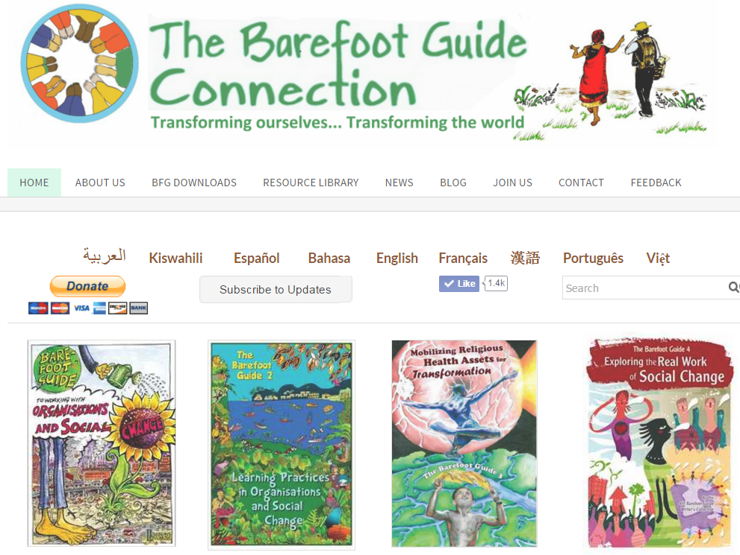

Barefoot Guide Writeshops and writing processes:
Surfacing invaluable experience and effective practice
It was a sunny morning when my parents received the most heart-breaking news about me. “Your child will never be able to walk” the doctor had said. Back at home, grandma got the news. She was in a shock, “This is a curse befalling our family”.
This was written by a woman from Kenya, a practitioner and community leader, who participated in the Barefoot Guide writeshop in the Netherlands in April 2016, aimed at assisting practitioners to surface their experiences and practices of inclusive development. It was her first time abroad and she felt a bit overwhelmed. On the first day of the workshop she doubted herself: “What can I contribute to a guide on inclusion? I am not a scientist or a doctor, I am just Brenda, I am not sure if I can write, I am not a writer!”

A few days later she read the first draft of her story out. The other participants were moved, some to tears and all were impressed by the rich and stirring story of her own journey of inclusion, to courage and creativity, against all odds. The story related how she had worked to organise scores of self-help groups for disabled people to not only support each other but also to engage the community and the system to change attitudes and policies, to become more inclusive. She helped them to see the depth and complexity of exclusion faced by people in Kenya, where tradition and modernity, simultaneously and paradoxically, bring both cohesion and exclusion, and what it takes to negotiate the meeting of these two worlds, so that excluded people may find their place, as equal beings.

But she was only one of fourteen participants and this is where the synergy of Writeshops came into play. Anouk is a Dutch woman who works with a range of initiatives to help local government and civil society to co-create solutions to inclusion challenges in the Netherlands. She brought both experience and a good conceptual grasp to the writeshop that helped others to see through the complexity of their experience to the essence of what matters. Tung, from Central Vietnam, has been working with government and disabled peoples organisations to foster economic opportunities and community cohesion in support of a more inclusive society. He brought perspectives, insights and questions about drawing government into community initiatives that the others had not considered, but which throw light on their circumstances as well. Biraj from India brought surprising questions and perspectives that knocked everyone out of their comfort zones. She herself was surprised at how her provocations were enjoyed. Each of the fourteen had their own unique contribution, and this being a process about inclusion, the challenge to deeply listen and stay open to “the other” made the experience itself particularly alive and engaging and for all of that, authentic.

The writeshop process gently guided them to help each other to surface, share and deepen their experiences, their questions and ideas, to face their writing doubts and fears, to surface hidden facets of practice and to create unique insights to share more widely and take back to their home countries for further work. And they are also gaining writeshop techniques for themselves to use back at home with their colleagues and communities to strengthen their sharing and learning processes towards continually improving practices. Writeshops not only help people to write well, they also help people to learn together in a more disciplines way, creating communities of practice that have real substance.

The Barefoot Guide Writeshops have enabled people like Brenda, Anouk, Tung and Biraj, whose valuable experiences and insights have never been made unavailable to the world, to contribute to a global body of knowledge required by policy makers, donors, practitioners and students. What they know, collectively, may very well be key to successful policies, approaches and practices of inclusive development.

Most Barefoot Guides were written over more than one writeshop with continuous writing, coaching, peer-review and editing processes between and after the different Writeshops, towards final publication.
Our Writeshops methodologies have developed over the past eleven years, improved as each Guide was written. Writeshops consist of a series of specific action learning-based writing and conversational exercises that are designed to help people, who struggle to write, to become writers. Experiences are collectively surfaced, and then deepened through analysis and comparative inquiry. The “inside stories” are sought, these being the less visible processes, the hidden dramas within and between actors, that world of assumptions, mixed feelings and often conflicting motives that, when reflected on, tell the real story of what unfolded. When the “inside stories” are brought to light then the real work and practice is revealed and can be learned from and then improved.

Out of these processes a variety of written drafts are developed which are then read and reworked through a number of peer feedback processes. Exercises in creative expression help writers to lift and enrich their language to better approximate the richness of reality and to express what they have learned in clear and simple ways.

The Process of the Barefoot Guide on Inclusive Development
This Barefoot Guide was conceived of in 2015 on the back of the Transition in the East Alliance publication “Embracing Practices of Inclusion (click to download) - Stories of how people in Georgia, Laos, Sri Lanka, Tajikistan and Vietnam made inclusive development happen in their societies”. The publication was also developed using Barefoot Guide writeshop methodologies. MCNV, one of the leading NGOs in the Alliance, felt that although the experiences from these five countries were invaluable, they could not be said to represent a global set of inclusive development practices. Using some of the remaining funds from the TEA publication MCNV teamed up with the Barefoot Guide Connection to initiate this new Barefoot Guide, drawing in a wider range of practitioners and their experiences. This is the design of the process:

- A small Editorial Group was formed in late 2015 to co-ordinate and support the whole process. This is in place.
- This group initiated a preparation process to develop the purpose and focus, to identify the right participants and to organise the whole process. This was done.
- A first Writeshop, of 5 days, was held in Alkmaar, the Netherlands in April 2016, to conceptualise, design and “kick start” the intended products, to develop first drafts, and to unlock the writing capacities of the practitioners.
- Now the practitioners have dispersed for a few months to do further research and writing, reconnecting with each other in peer groups via email and skype. By October they will have supported each other to develop a penultimate draft in preparation for the second Writeshop. At this stage the Editorial Group is coordinating the peer group process.
- Meanwhile, further contributions are being elicited through the various networks to fill in gaps in the publication, supported by the Editorial Group. A call is due to go out in June 2016.
- A second Writeshop, of ten days, is intended in October 2016, where the drafts are further engaged, deepened and connected, and from which further pieces will emerge. Some of the new contributors may join the process. Final drafts will be developed during or shortly after. The illustrators will join the process to understand and gather ideas.
The publication is finalised by the editorial group, with the illustrators and layout artists.
The due date is March 2017.

Financial Contributions
The process is being financed in three ways:

- MCNV put up an initial seed contribution to cover much of the costs of the first writeshop;
- Each participating organisation/writer is contributing an amount to cover some of the costs;
- Funds are being sought to cover the shortfall. If you are a donor or know a donor who might contribute, please make contact.

The Community Development Resource Association of Cape Town, South Africa, which hosts the finances of the Barefoot Guide Connection, is overseeing the finances from after the first writeshop.

If you would like to contribute please contact:
Doug Reeler - doug@cdra.org.za
Akke Schuurmans - akke.schuurmans@mcnv.nl

In your email provide an idea of what it is that you would like to write about. You may not yet know exactly what you will say, but have a strong feeling that what you have is of value. If we like what you are suggesting, then we will help you to explore and develop it into a piece of writing. If you have already written something, then please send that to us.

